|  |  |  |  |  |  |  |  |
| --- | --- | --- | --- | --- | --- | --- | --- |
| **Date:** | **23-05-20** | | | | **Name:** | **SAHANA C** | |
| **Sem & Sec** | **VI B** | | | | **USN:** | **4AL17CS116** | |
| **Online Test Summary** | | | | | | | |
| **Subject** | | **OR IA Test** | | | | | |
| **Max. Marks** | | **30** | | **Score** | | **30** | |
| **Certification Course Summary** | | | | | | | |
| **Course** | **Ethical Hacking** | | | | | | |
| **Coding Challenges**   1. **Write a python program to print count of positive and negative numbers in a list** 2. **Write c program to generate n triangular numbers** | | | | | | | |
| **Certificate Provider** | | | **Great learning** | **Duration** | | | **6 days** |
| **Status:Completed** | | | | | | | |
| **Uploaded the report in Github** | | | | **Yes** | | | |
| **If yes Repository name** | | | | **https://github.com/sahanasanu/Daliy-status** | | | |
| **Uploaded the report in slack** | | | | **Yes** | | | |

**DAILY ONLINE ACTIVITIES SUMMARY**

**Online Certification Details**

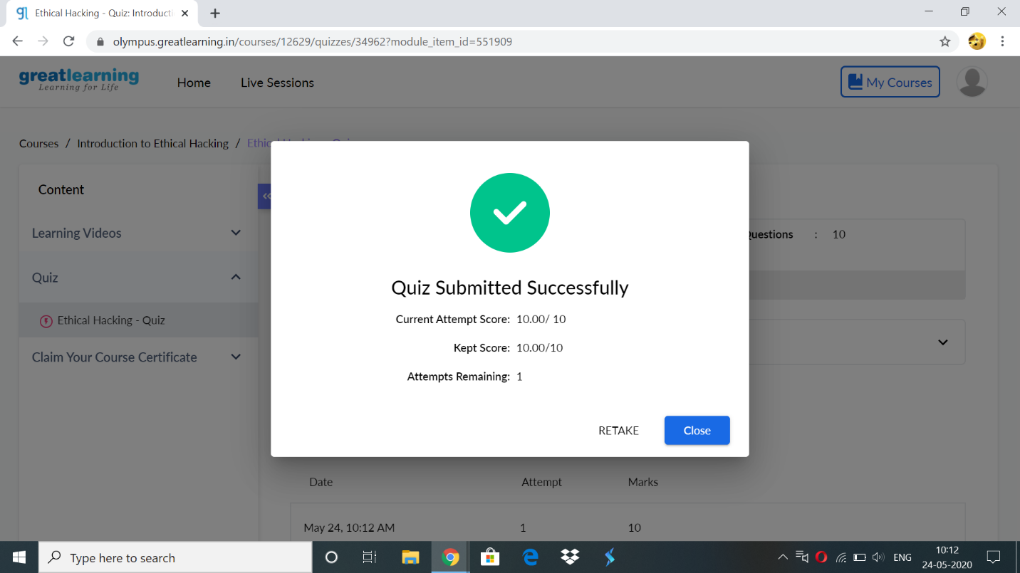

Certificate: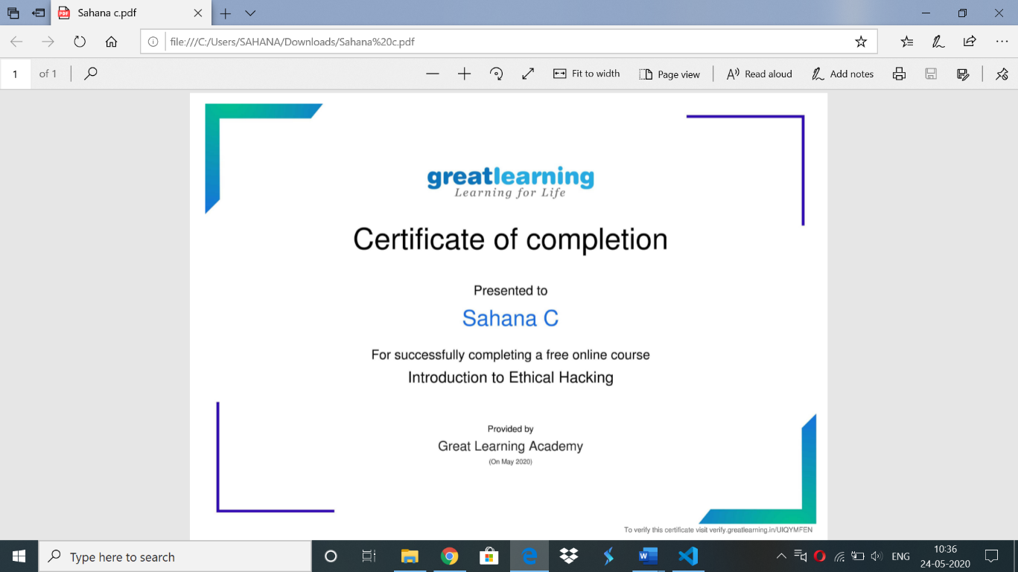

Online codding challenge:

// C Program to find Triangular Number Series

#include <stdio.h>

// Function to find triangular number

void triangular_series(int n)

{

for (int i = 1; i <= n; i++)

printf(" %d ", i*(i+1)/2);

}

// Driven Function

int main()

{

int n;

printf("enter the number:");

scanf("%d",&n);

triangular_series(n);

return 0;

}

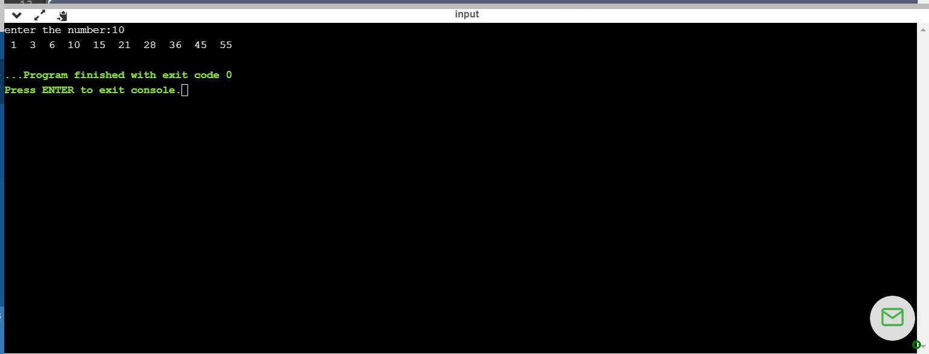

2)python program